The report from sonerQuabe :

Before :

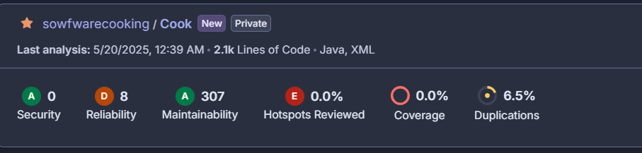

Covarage :

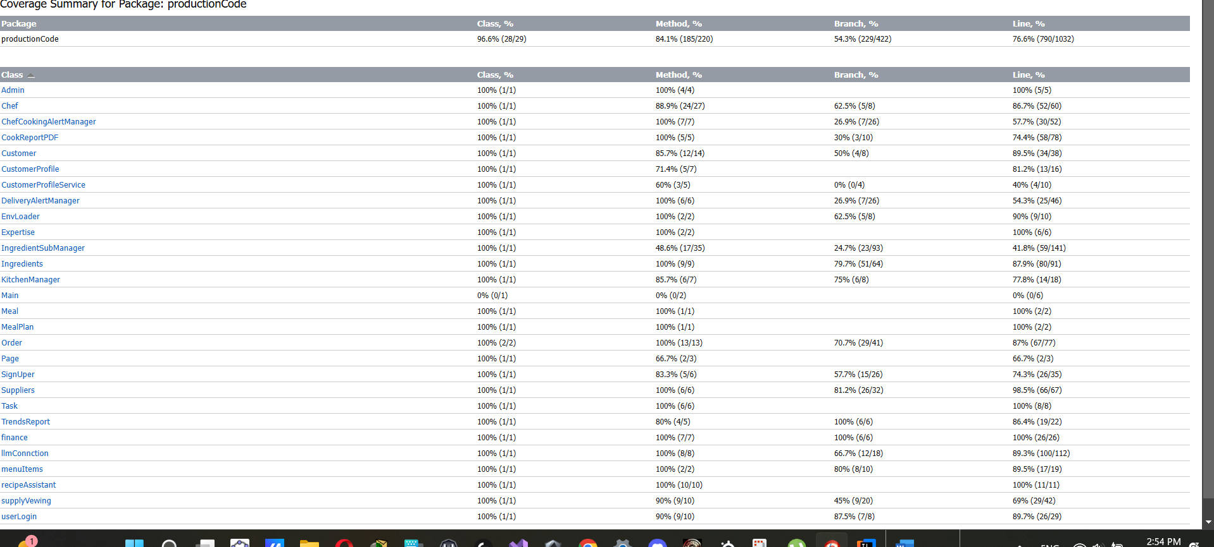

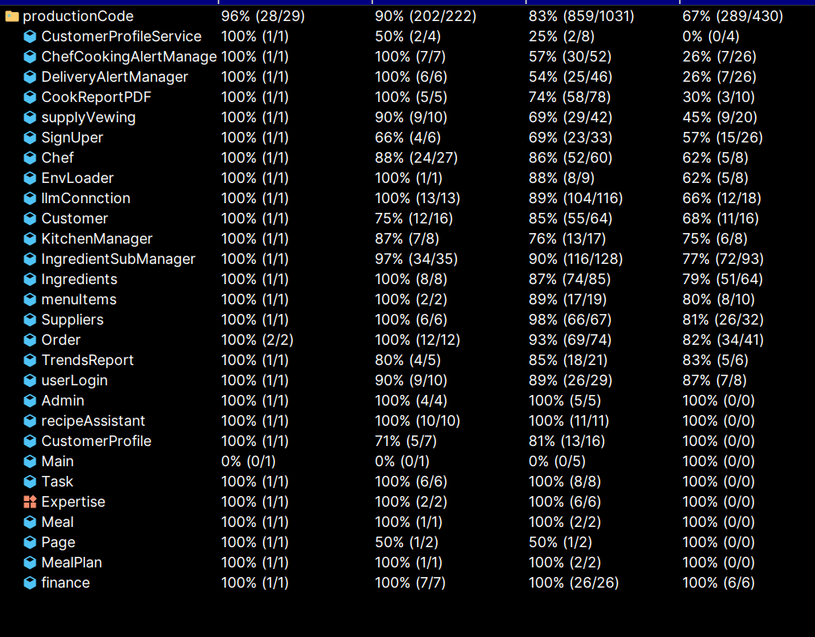

Some Maintainability issue :

Before:

Problem rename the package Add a private constructor to hide the implicit public one.

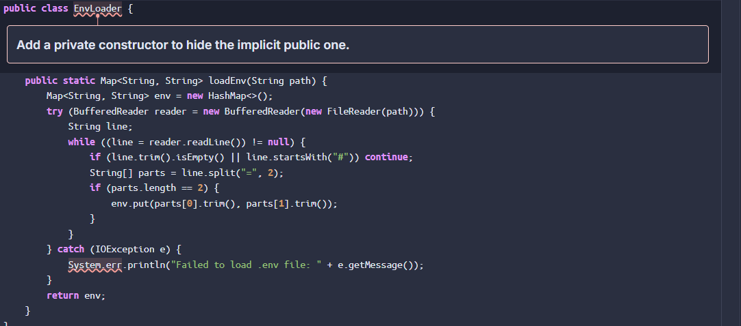

After :

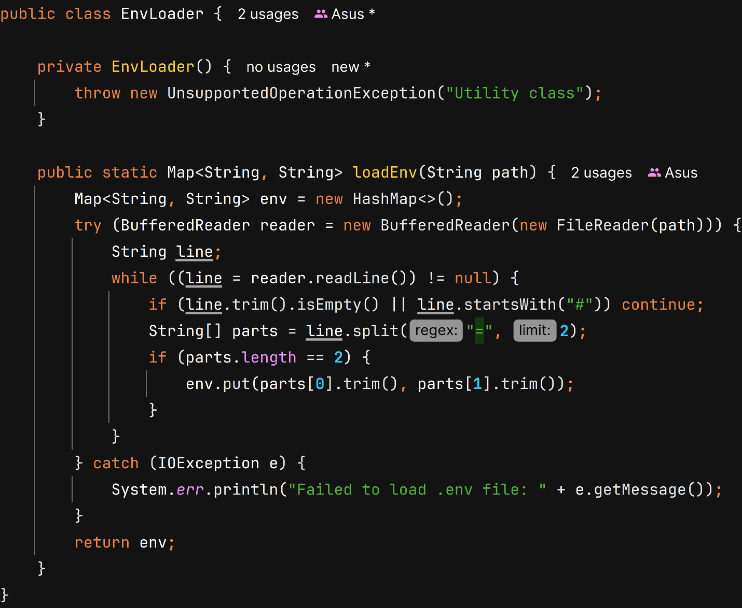

Problem : Define a constant instead of duplicating this literal "UTF-8" 3 times.

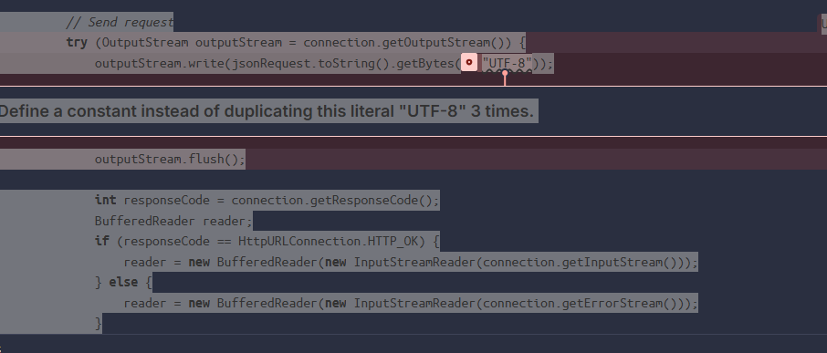

After :

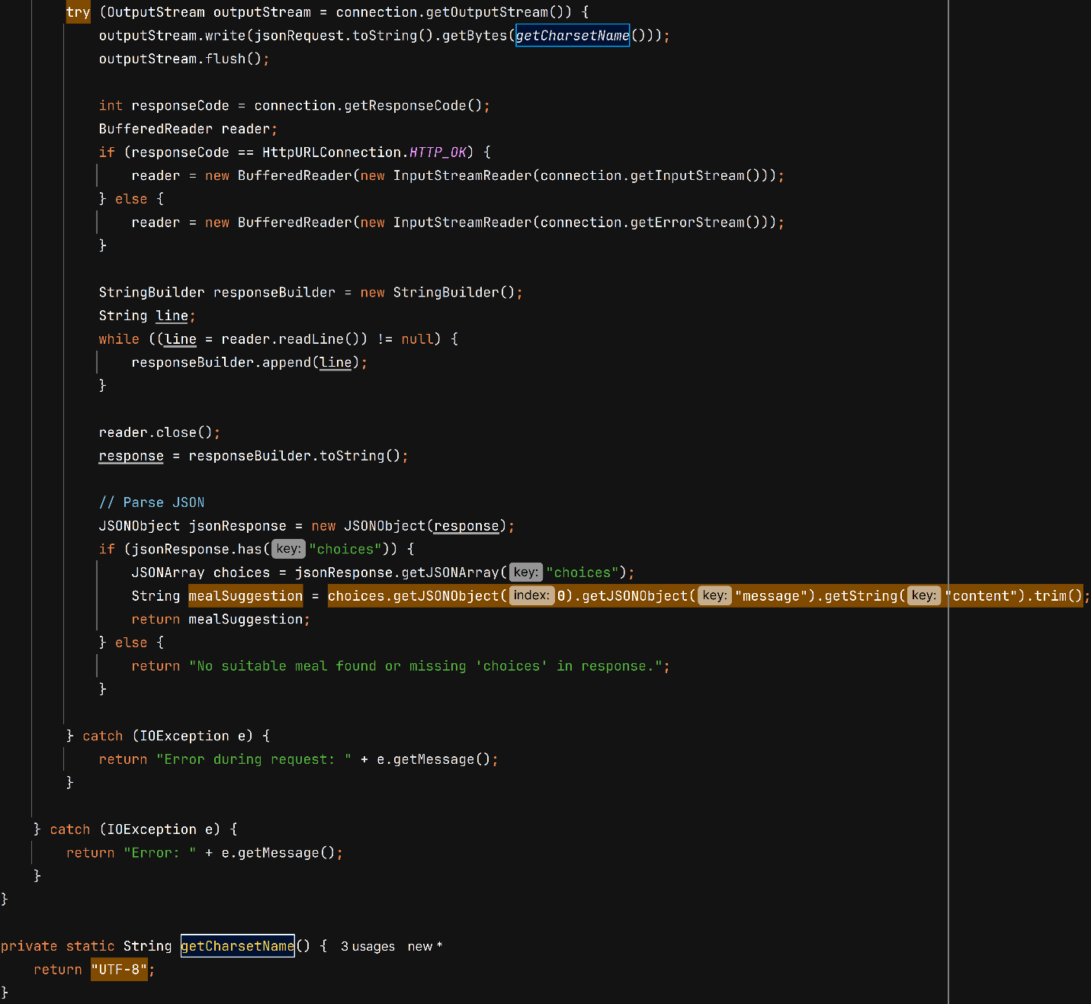

Bad smell 3 )

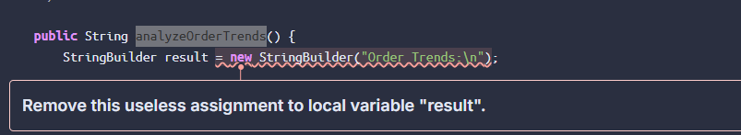

Result

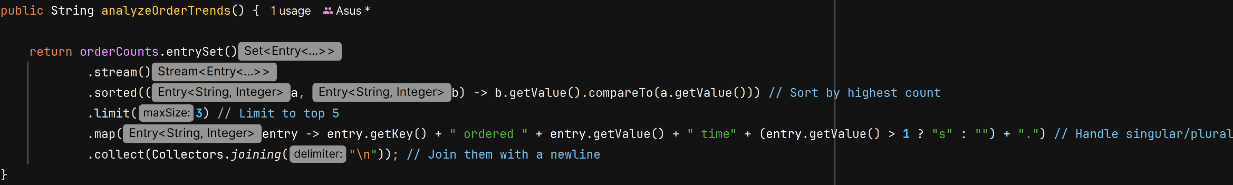

Smell number 4

"entrySet()" should be iterated when both the key and value are needed

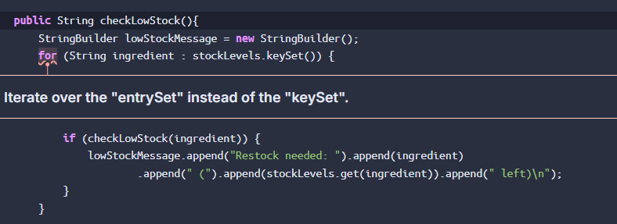

Solve it   
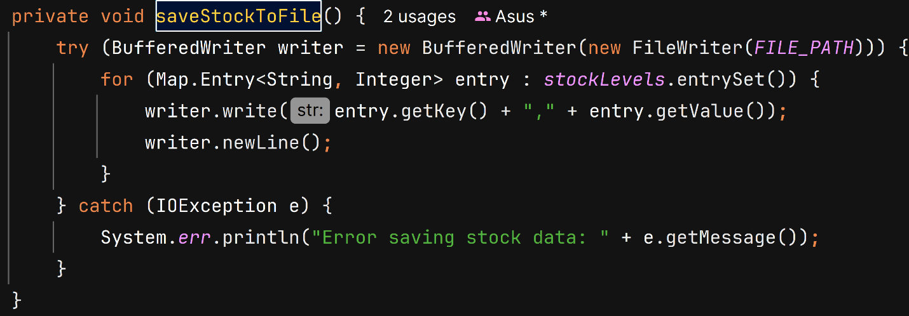

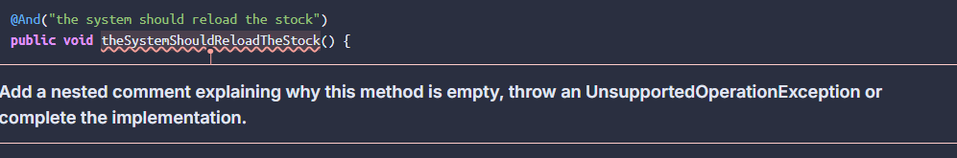problem : Add a nested comment explaining why this method is empty

Solve :

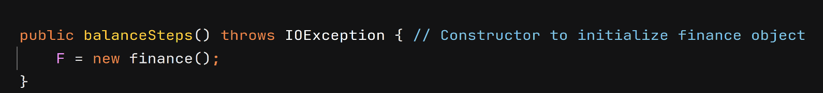

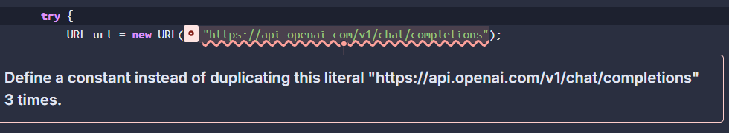

**Define a constant instead of duplicating this literal**

After :



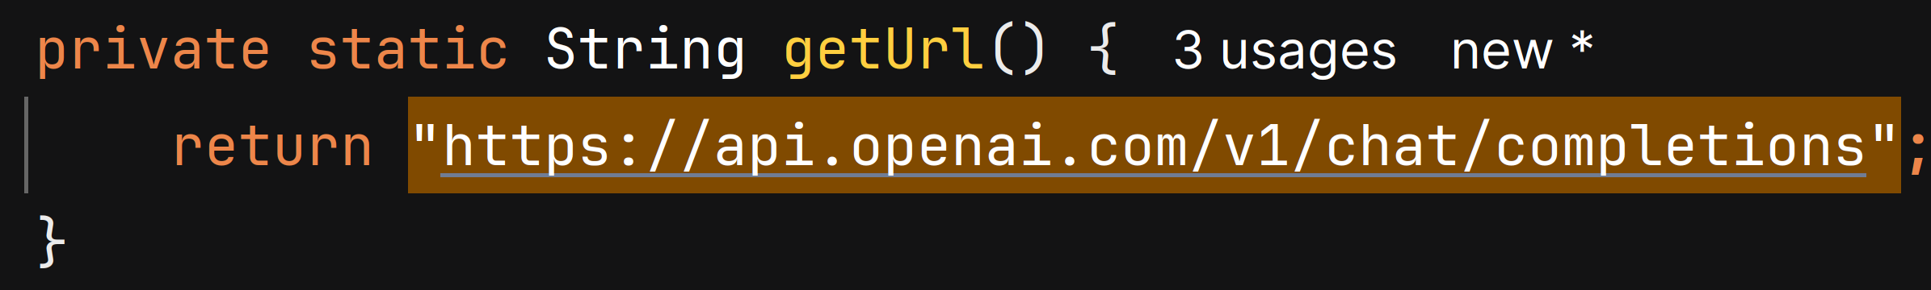

Same problem :



Solve :





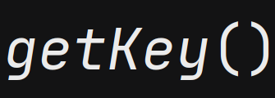

Same   
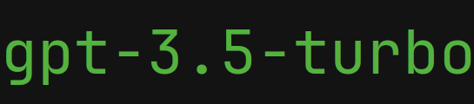

Solve

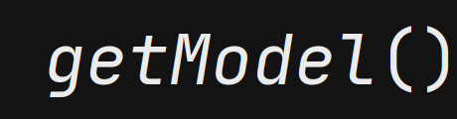

RENAMING issue

ProductionCode

;

**Rename this package name to match the regular expression '^[a-z_]+(\.[a-z_][a-z0-9_]*)*$'.**



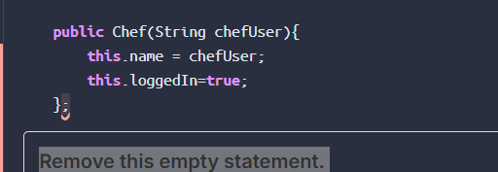

**Remove this empty statement.**

